Guide to the Considerations about Re-opening Synagogue Buildings
Published by a working group of
the Reform, Conservative, and Reconstructionist Movements with the Secure Community Network
Version 2 – Updated 7/16/2020

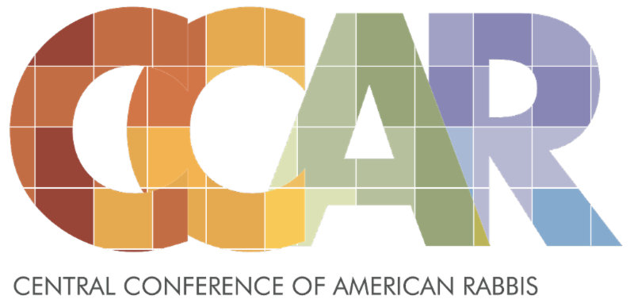
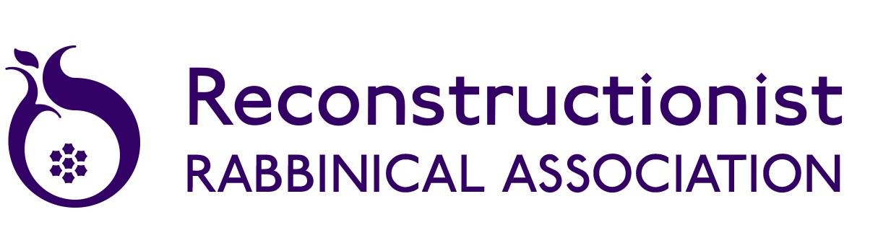
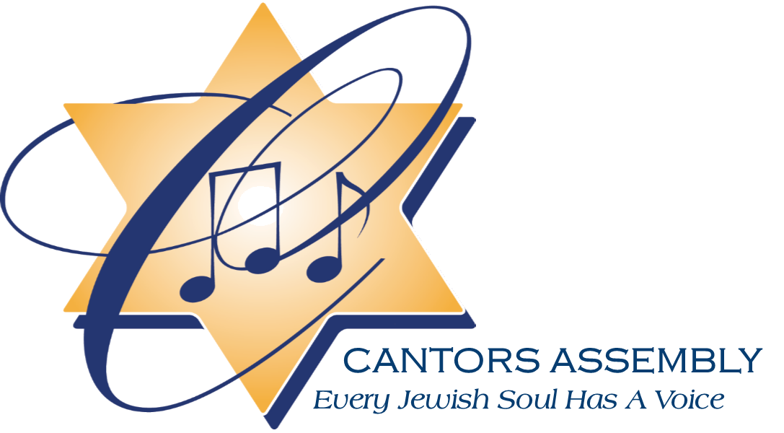
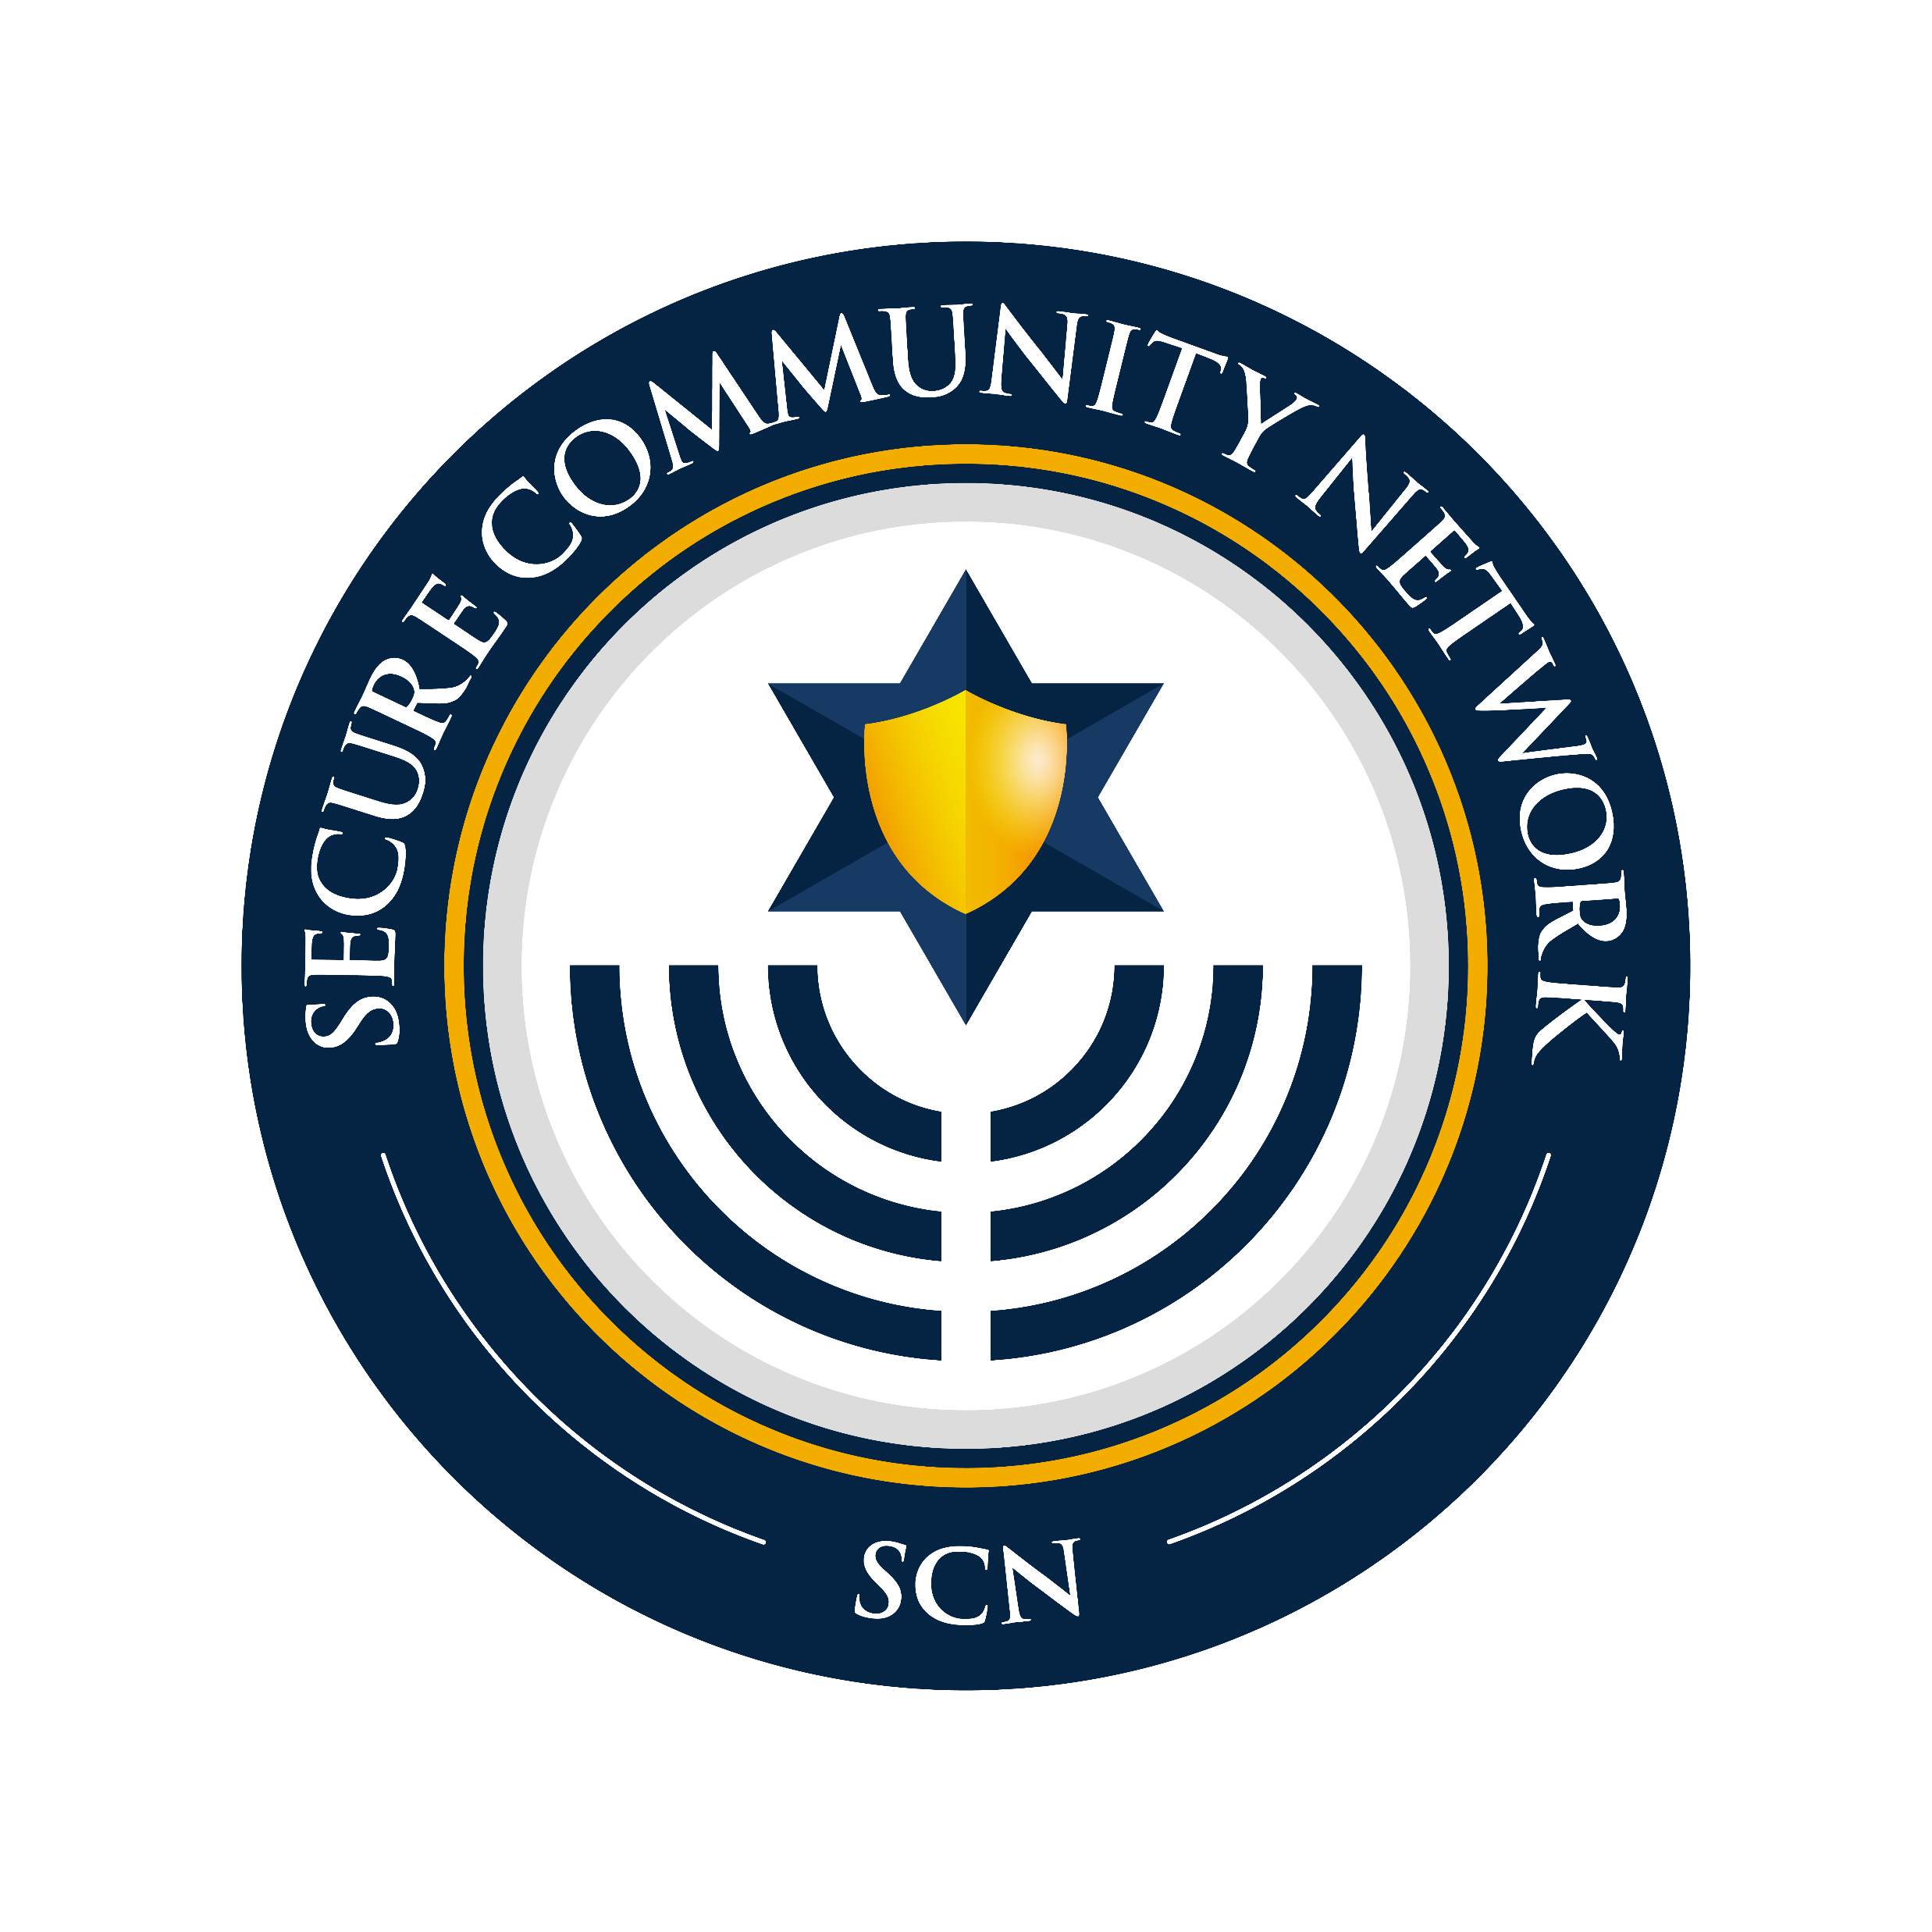
As national, state, and local health authorities begin to allow additional activities in certain communities, congregational leaders will begin to consider the process of re-opening. We understand that economic and communal pressure, the loneliness and isolation of congregations, and the desire to “get back to normal” bias leaders in favor of re-opening. As articulated in the rabbinic statements linked to below, Jewish values obligate us to consider broader implications of our actions, including the risk to the lives of our clergy, seminary students, employees, volunteers, our congregants, and those who would come in contact with them.

These re-opening tools are not meant to create the basis for re-opening but rather give you some guidelines to help consider whether you should. At every step of the way, you must consider the risks of something going wrong and the implication that your decisions might be responsible for that.

These re-opening tools are meant to be used as templates for your individual decision-making process.

- The guidance from the Secure Community Network provides a wealth of information and recommendations that can help shape your approach and your decisions. You can find it all of their re-opening guidance, including the Comprehensive Resumption of Operations and Reopening Guidance Document at https://securecommunitynetwork.org/resumption-of-operations-and-organizational-reopening-working-group
- The decision tree tool is based on those produced by the Center for Disease Control on May 14, 2020 and is tailored to congregations.
- The phased re-opening template is a generic version based on several examples that we have seen from congregations.
- The specific guidance on singing is a compilation from the best sources available at this time.
- The document from Hillard Heintze is a supplement. Hillard Heintze is an enterprise security risk management firm in partnership with Secure Community Network and recommended by them to answer supplemental questions.

As we repeat on every page of this document, every congregation faces a different situation and must tailor its decision making according to applicable guidelines and congregational and Jewish values. These include but are not limited to national/local/state/provincial authorities; nature of physical plant including size of rooms, layout and availability of HVAC and ventilation; the extent to which clergy, staff, and volunteers are not constrained in ability to return by health or living situation; resources available to maintain the building, among other factors. .

Every congregation should take into consideration the following principles.

- Having a plan for re-opening does not imply that you need to re-open, nor are the existence of these tools and endorsement of re-opening. You may create your plan and still decide that it is not the right time to re-open for a variety of reasons.
- Start with a discussion of the Jewish values that should guide your thinking. All of the major movement rabbinic associations have created statements and you can find them at the links below:
Central Conference of American Rabbis/Union for Reform Judaism Guidelines on Values-Based Decision Making: Returning to in-person gatherings during the Covid-19 Pandemic
https://www.ccarnet.org/ccar-urj-guidelines-on-values-based-decision-making-returning-to-in-person-gatherings-covid-19/

Reconstructing Judaism/Reconstructionist Rabbinical Association Statement on Re-Opening
https://www.reconstructingjudaism.org/news/reopening-our-institutions

Reconstructing Judaism: Jewish Values and Coronavirus https://www.reconstructingjudaism.org/center-jewish-ethics/coronavirus

Rabbinical Assembly: Jewish Values Regarding Physical Reopening of Our Institutions https://www.rabbinicalassembly.org/sites/default/files/2020-04/COVIDvaluesstatementApril2020logo.pdf

Orthodox Union and Rabbinical Council of America Guidance to Shuls and Communities on Re-Opening
https://www.ou.org/assets/OU-Guidance-To-Shuls-And-Communities-5-8-2020_F-1.pdf

- We strongly recommend that personal situations of clergy, seminary students, staff, and volunteers are taken into consideration as you make re-opening decisions. There may be confidential health matters that they are living with that keeps them from returning to the building. You must comply with labor and health practices that allow for employees to stay home without having to disclose what their condition is.
- As you plan for reopening, you should also plan for how to move backwards or close down again. Your local public health situation may change and your synagogue may need to alter reopening plans.
- Reopening should not be a rushed process. If you reopen too quickly, you could accidentally expose congregants, staff, and volunteers. It is OK to bias towards being conservative given that people’s lives are at risk. Consult with your insurance company or local counsel to determine legal risk.
- Reopening should happen in phases and for certain building uses but not others. The materials below provide for creating phased and partial reopening.
- Form a task force to make decisions on reopening so that you can bring the right resources to the decision. Work in sacred partnership, understanding that different people from a variety of background (lay/clergy, race, gender, disability, etc;) bring different views and experiences that should be heard, but that it should be clear who has ultimate authority for the decision.
- Be sure to check with your national/local/state/provincial health department on all decisions, and consult with the local public-school systems, especially when making decisions that involve youth.

Because local conditions vary, the decision to stay closed or to open is still yours. The use of these tools does not imply endorsement by the Working Group.

This document will continue to be updated as conditions change and more becomes known about Covid-19.

June 18, 2020

Cross Movement Working Group

Tamar Anitai, Central Conference of American Rabbis
Amy Asin, Union for Reform Judaism
Jack Feldman, National Association for Temple Administration
Allison Gelman, Union for Reform Judaism
Tresa Grauer, Reconstructing Judaism
Rabbi Maurice Harris, Reconstructing Judaism
Harry Hauser, North American Association for Synagogue Executives
Rabbi Ashira Konigsburg, Rabbinic Assembly
Leslie Lichter, United Synagogue of Conservative Judaism
Michael Liepman, National Association for Temple Administration
Rabbi Stan Schickler, RJE, Association of Reform Jewish Educators
Kathy Schwartz, RJE, Association of Reform Jewish Educators
Cantor Steven Weiss, American Conference of Cantors
Kaitlyn Weitzel, Secure Community Network

Re-Opening Decision Tree

As national/local/state/provincial health authorities begin to allow additional activities in certain communities, congregational leaders will begin to consider the process of re-opening. We understand that economic and communal pressure, the loneliness and isolation of congregations, and the desire to “get back to normal” bias leaders in favor of re-opening. As articulated in the rabbinic statements linked above, Jewish values obligate us to consider broader implications of our actions, including the risk to the lives of our clergy, seminary students, employees, volunteers, our congregants, and those who would come in them.

These re-opening tools are not meant to create the basis for re-opening but rather give you some guidelines to help consider whether you should. At every step of the way, you must consider the risks of something going wrong and the implication that your decisions might be responsible for that.

This decision tree is based on one published by the Centers for Disease Control on May 14, 2020 and has been tailored for use by congregations. It must be tailored for each individual congregation.

You can use the decision tree to consider opening your building for specific cases or for multiple cases. For example, it likely will be possible to open as a workspace for clergy and staff before opening for Shabbat services. Here are a sample set of cases for you to consider:

  - Workspace for individual clergy, staff, seminary students, and volunteers
  - Workspace for internal meetings
  - Committee, task force, volunteer meetings
  - Pastoral care
  - Small lifecycle ceremonies
  - Streaming worship or other events without participants present
  - Worship and larger lifecycle ceremonies
  - Children’s programming
  - Youth programming
  - Family programming
  - Adult programming

For any individual use, start with Step 1 of the decision tree. If you can answer all of the questions in Step 1 with a “yes,” move on to Step 2. Continue until you have answered the questions in all three steps with a “yes.” As a final step, do another values check. If you are still confident that you can open safely and in a way that is consistent with your values, you can consider opening for the purpose you analyzed.

The decision tree will be updated as conditions change.

Decision tree Step 1: Are we legally able to open for this use, and is it consistent with our values?

Questions to consider:

- Will reopening be consistent with applicable national/local/state/provincial orders and any applicable licensing guidelines?
- Are we ready to protect employees and participants who are at higher risk for severe illness or who live with people at higher risk by providing for them to stay home without breaking confidentiality? Are we able to provide options for those who commute on public transportation, or those with children whose childcare or school options are not available, or who cannot return to the building for other reasons? Will we provide employees with paid leave if they cannot work due to Covid-19 restrictions, acknowledging that not everyone can work from home?
- Is opening consistent with our congregation’s values and Jewish values?

If any of these are answered no, STOP and wait until you can answer yes to all.
If all are yes, move on to Decision tree Step 2.

Decision tree Step 2: Once open, will we be able to operate safely?

- Has our facility been fully prepared?
- Can we require healthy hygiene practices such as handwashing and wearing masks, including for disabled people and people in wheelchairs?
- Are we able to clean and disinfect the building per recommendations?
- Do we have a plan for safely providing restrooms and cleaning them on a regular basis?
- Are we able to provide ventilation safely?
- Can we require social distancing through physical barriers, changing layouts of workspaces and gathering spaces, revised traffic flows, closing or limiting access to communal spaces, staggering work hours, and limiting large events per national/local/state/provincial guidelines?
- Are we clear about what we will do about shared ritual objects?
- Do we have a plan for allowing usual use of supplies, office equipment and machinery, kitchen, common work areas, handling of any food?
- Do we have a plan for limiting attendance, if necessary?
- Can we train all employees, volunteers, contractors, and participants on protocols?
- Can we create communications and place signage to enforce new traffic flows and procedures?
- Will we track attendance according to national/local/state/provincial health rules in order to do contact tracing?
- If someone contracts Covid-19 within 14 days of being in our building, how will we communicate with others who were there at the same time, with members and staff at large, including maintaining confidentiality and providing pastoral care?
- Do we have enough cleaning supplies and personal protective equipment to re-open and will we provide that to employees?
- Do we have a plan in place for when a non-employee arrives without PPE to make a delivery, provide a service, do maintenance, etc;?
- Are we clear about what personal protective equipment we will provide and what we expect employees, volunteers, and attendees to bring?
- Can we afford the additional expense or lost revenue of reopening, if any?
- Have we made decisions about how to balance our security needs with our health needs?

If any of these are answered no, STOP and wait until you can answer yes to all.
If all are yes, move on to Decision tree Step 3.
Decision tree Step 3: Is ongoing monitoring in place to ensure that we maintain a healthy environment once open?

- Have we identified an individual or group to regularly monitor national/local/state/provincial guidelines and to communicate that to leadership?
- As national/local/state/provincial guidelines change, are we flexible enough to change our plans as needed?
- Can we implement procedures to check for signs and symptoms of employees, volunteers, and participants upon arrival, including asking them to leave if they have signs or symptoms?
- Can we ensure that anyone who is or becomes sick will leave the building?
- Do we have a plan in place to replace a sick employee or volunteer, if necessary?
- Do we have a plan in place to communicate expectations with anyone entering the building?
- Have we included training for bias for those who are monitoring compliance with policies, including bias against people of color who are wearing masks?
- Are we clear about who will enforce policies for someone who is not following guidelines or if someone becomes belligerent?
- Will we allow for any exceptions to our policies, and who will decide and enforce?
- Will we provide an online option for people (clergy, staff, all participants) who are not able to return to the building because of restrictions due to Covid-19?
- Will we continually monitor our inventory of cleaning supplies and personal protective equipment and restock when necessary?
- Will we be able to regularly clean the facility in accordance with national/local/state/provincial recommendations?
- Will we be able to regularly communicate changes to policy with anyone entering the building?
- How will we capture feedback so that employees, participants, and those entering the facility who are concerned about non-compliance with our stated policies can provide such feedback without fear of reprisal?
- Do our personnel policies allow for flexible/paid leave or remote working even once we open because not everyone will be able to be in the building?
- Will we continually review, update, and communicate changes to health and safety actions?
- Are we able to quickly close down again if needed? Do you have a plan to do that, if necessary?
- Have we established limitations/requirements for off-site gatherings?

If any of these are answered no, STOP and wait until you can answer yes to all.
If all are yes:
- Consider the risk of something going wrong. Are you prepared to be on the front page of your local newspaper or on social media with that error? Is your plan so strong and implementation expected to be so good, that you could be in the press for the excellence of your work?
- Have you consulted with your insurance agent and are you able to accept liability, if any, if you open too soon?
- Check congregation values and Jewish values again.

Because local conditions vary, the decision to stay closed or to open is still yours. The use of these tools does not imply endorsement by the Working Group.

Phased Re-Opening Plan

As national/local/state/provincial health authorities begin to allow additional activities in certain communities, congregational leaders will begin to consider the process of re-opening. We understand that economic and communal pressure, the loneliness and isolation of congregations, and the desire to “get back to normal” bias leaders in favor of re-opening. As articulated in the rabbinic statements linkedabove, Jewish values obligate us to consider broader implications of our actions, including the risk to the lives of our clergy, seminary students, employees, volunteers, our congregants, and those who would come in them.

These re-opening tools are not meant to create the basis for re-opening but rather give you some guidelines to help consider whether you should. At every step of the way, you must consider the risks of something going wrong and the implication that your decisions might be responsible for that.

This phased re-opening plan is a tool to guide you in thinking about re-opening. It should be used in tandem with other guidance from your national/local/state/provincial health authorities, and other tools.

The tool is broken into phases, but the use of the term phases is NOT meant to coincide with phases that your local health authorities are using. These are phases that any congregation could use, no matter where they are.

While this tool helps you to establish a timeline and set of criteria for re-opening, it is not an endorsement of re-opening. Each congregation will need to make that decision by itself based on its particular situation.

*****

Sections: This is a sample of the sections you should have in your re-opening plan. You may add phases or guidance in each phase per your local conditions

Preliminary Sections
- Statement of values – use your own values statement or use statement from your movement:

Central Conference of American Rabbis/Union for Reform Judaism Guidelines on Values-Based Decision Making: Returning to in-person gatherings during the Covid-19 Pandemic
https://www.ccarnet.org/ccar-urj-guidelines-on-values-based-decision-making-returning-to-in-person-gatherings-covid-19/

Reconstructing Judaism/Reconstructionist Rabbinical Association Statement on Re-Opening
https://www.reconstructingjudaism.org/news/reopening-our-institutions

Reconstructing Judaism: Jewish Values and Coronavirus https://www.reconstructingjudaism.org/center-jewish-ethics/coronavirus

Rabbinical Assembly: Jewish Values Regarding Physical Reopening of Our Institutions https://www.rabbinicalassembly.org/sites/default/files/2020-04/COVIDvaluesstatementApril2020logo.pdf

Orthodox Union and Rabbinical Council of America Guidance to Shuls and Communities on Re-Opening
https://www.ou.org/assets/OU-Guidance-To-Shuls-And-Communities-5-8-2020_F-1.pdf

- Intention to follow national/local/state/provincial health guidelines – make a clear statement that shows you are following the law and health department guidance
- Process for developing this plan, for updating the plan, and for monitoring compliance – be clear about how it was done, who was involved, and how it will be updated as understanding of the virus continues to develop
- Social distancing protocols (sample)
  - Stay 10 feet away from others whether praying, walking, working, or otherwise engaged
  - Avoid conversations and tasks that require close face-to-face contact with others when possible.
  - Avoid all contact with others whenever possible (e.g., handshakes, hugs).
  - Avoid touching surfaces that may have been touched by others when possible.
  - Distance themselves from anyone who appears to be sick.
  - Follow designated traffic flow patterns, including avoid gathering when entering and exiting the facility and only entering and exiting via designated areas.
  - Follow any posted signage regarding COVID-19 social distancing practices.
  - Disinfect any surfaces touched with wipes, if possible.
  - Avoid touching their face.
  - Avoid nonessential gatherings.
  - Limit the number of individuals in common areas at all times.
  - Avoid using common areas.
Phases of Re-Opening
- Closure – no building use except for maintenance, cleaning, and security check
  - Until congregations are allowed to open by national/local/state/provincial health authorities and we are prepared to do what it takes to operate safely, we will remain closed
  - All functions should be performed remotely
  - Only necessary maintenance, cleaning, and security checks should be done

- Phase One – very limited re-opening for office and outdoor gathering, if practical
  - List the health authority conditions that must be met in order to move to Phase One – for example, four consecutive weeks of declining cases in our county according to our county health department
  - List the policy for tracking attendees and notifying attendees if a participant has become sick
  - List overall procedures – use of face masks, social distancing, etc.
  - List the building uses that will be permitted, for example
    - Single family limited attendance b’nai mitzvah and weddings can take place
    - Limited attendance outdoor events can take place
    - No meetings or appointments
    - Clergy and staff may work from the building if their offices can be kept closed and they wear masks outside their offices. Designate an approval person to track who is in the building each day
  - No food services
  - No shared ritual objects
  - Designate rules for use of restrooms
  - Also designate what clergy and staff can or cannot do in other spaces – no shiva minyanim, hospital, or home visits
  - Alternative arrangements available for clergy, staff, and volunteers who have risk factors and cannot perform duties

- Phase Two – limited programming with attendance restrictions and social distancing
  - List the health authority conditions that must be met in order to move to Phase Two, acknowledging that it might be required to move back to Phase One. For example, after four consecutive weeks of declining cases, an additional two consecutive weeks of declining cases
  - List the policy for tracking attendees and notifying attendees if a participant has become sick
  - List overall procedures – use of face masks, social distancing, etc.
  - List the building uses that will be permitted
    - Limited attendance programming with masks and social distancing
    - Larger attendance, but still with limits, outdoor events with masks and social distancing
    - Meetings and appointments with distancing, ventilation, and cleaning. Designate an approval person to track who is in the building each day
  - No food service
  - No shared ritual objects
  - Designate rules for use of restroom
  - Designate what clergy and staff can or cannot do in other spaces – no shiva minyanim, hospital, or home visits
  - Alternative arrangements available for clergy, staff, and volunteers who have risk factors and cannot perform duties

- Phase Three – full programming with minor restrictions
  - List the health authority conditions that must be met in order to move to Phase Three, acknowledging that it might be required to move back to Phase Two. For example, an additional two weeks of declining cases in our county past the six weeks that got us to Phase Two, significant treatment options widely available, etc;
  - List the policy for tracking attendees and notifying attendees if a participant has become sick
  - List overall procedures – use of face masks, social distancing, etc;
  - Programs will run with attendance limits, social distancing, and masks depending upon size and room usage
  - Food service based on health department recommendations
  - Limited use of shared ritual objects based on health department recommendations
  - Designate rules for use of restroom
  - Designate what clergy and staff can or cannot do in other spaces – shiva minyanim if limited attendance, hospital visits, home visits
  - Alternative arrangements available for clergy, staff, and volunteers who have risk factors and cannot perform duties
- Phase Four – no restrictions
  - Health authority conditions would include herd immunity, widespread availability and compliance with vaccination, or significant treatment options, and in accordance with CDC guidelines.
  - No restrictions on programming

Examples of actual congregation plans can be accessed through your movement.

Guide for Decision-Making about Singing: To Sing or Not to Sing in a Time of COVID-19

Prepared by Cantor Steven Weiss
Immediate Past-President of the American Conference of Cantors
(In consultation with Cantor Claire Franco, President of the American Conference of Cantors, Marla Bentley, President of the Guild of Temple Musicians and Cantor Rosalie Will, Director of Worship for the Union for Reform Judaism)

There is risk associated with everything that we do. Congregational professionals and lay leaders need to assess the potential risk of in person communal worship – focusing parts of worship that are of a higher risk. When making decisions regarding worship, lay leaders and professionals MUST use their own national/local/state/provincial regulations. The following guidance regarding singing and music are general recommendations. Please consult with your local boards of health for specific guidelines for your location.

Please note that we are not providing medical or legal advice. We are presenting information in a way to generate conversation and encourage additional research as you make decisions for your congregation.

“Let everything that breathes praise God…. Hallelujah”
-psalm 150

As synagogues of all sizes and types consider resuming worship in public spaces, professional and lay leaders must weigh the risks associated with singing and playing certain types of instruments in a confined space. Music is integral to Jewish worship and it is difficult to imagine prayer without it. David played in the time that the Temple stood. So, even in this challenging time must find a way to include music in our synagogue experiences.

What do we know about the Covid-19 virus?

The information presented below is based on the current understanding of how Covid-19 spreads:
- The virus spreads mainly person to person
- Between people who are closer than 6 feet
- Through respiratory droplets when an infected person coughs, sneezes talks or sings
- Droplets land in mouths or noses of people in close proximity
- Contact with surfaces where droplets have “landed”

The following are things to consider when planning for worship inside a sanctuary:

Solo and Choral Singing

While information about the potential spread of COVID-19 is still incomplete, medical, scientific, and public health experts agree that:

- Speaking produces about 10x more aerosols and singing about 60x more than breathing which produces only a small number of aerosols.
- Volume matters. The number of aerosols generated when public speaking or singing is impacted by how loud the speech or singing is. The louder the speaking or singing, the more aerosols are produced and the further they appear to travel. There are additional studies that suggest that the aerosols produced can stay suspended in the air for long periods of time.
- Face coverings, while required, may not completely prevent spread of the virus by the person speaking or singing.
- Recognizing that there is deep emotional pain associated with the loss of choral singing, until such a time as better treatments or a vaccine is available for the treatment of COVID-19, all experts agree that choral singing in indoor spaces should not occur. The level of risk associated with placing choir members in close vicinity with the number of aerosols being released is too high a risk for congregations to bear.
- Singing with masks should also be avoided. Studies have shown that it can be hazardous to someone with heart or breathing conditions like (asthma/COPD). But even for healthy people, singing with a mask can cause dizziness or headaches.

Communal Singing

Communal singing (by the congregation) is equally important in Jewish worship. The role of the Kahal (community) cannot be underestimated and yet, at the same time, the risks are just as great as that of organized choir singing. Communal in-person singing should be discouraged. If services are occurring outdoors and significant social distancing can be achieved, the risk of transmission is lessened but not eliminated.

What about humming?

The impact of humming is not yet fully known. It is likely that loud humming may have the same effect as choral singing. However, soft humming with a face covering might be an acceptable risk.

“Singing together in congregations is a practice that we love dearly and are eager to promote, but loving our neighbor is job one here and so the fine for fasting from this wonderful practice may be longer than any of us would like.”
Rev. John Witvliet – expert on Worship

Can a Cantor or Soloist sing safely with an accompanist in the same room at the same time?

While there is still risk associated with any type of indoor singing, there are steps one can take to mitigate the risk.
- Have the accompanist wear a form fitting (N95 or other type) of mask
- Place the Cantor/Soloist in a well-ventilated room. If it is possible to open doors and windows to add ventilation, that would be optimal
- Consider placing the accompanist as far away from the Cantor/Soloist as possible
- As soon as the singing is completed all parties should leave the room

Can there be any other individuals in the room?

The answer to that questions depends on the size of the room that you are in. If you are in a small chapel and it is not possible to have at least 20-30 feet in all directions separating the cantor/soloist from the Rabbi or other service leader, then it should NOT be done. If the room is large and a significant amount of space can be created between the person who is singing and others, then it may be possible. Again, if the other parties in the room wear masks and other protective devices are used such as plexiglass shields, this can further decrease the risk. Consult with local officials for specific guidelines of what you can do to mitigate risk in your space.

What about the blowing of the Shofar for the upcoming High Holidays?

The call of the Shofar is a high point of Rosh Hashanah worship. Like singing, studies suggest that the use of wind instruments can create aerosols nearly 100x the aerosols of just breathing. So, too for the blowing of the Shofar. So, how can it be done safely?
- Consider placing the Shofar blower in an outdoor space
- If you congregation’s interpretation of halacha allows, pre-record the Shofar being blown in the sanctuary and use the recording during worship

What can we do about music?

(URJ Congregations)
Each congregation will determine the delivery of their worship services. If your worship is virtual, you may consider using prepared liturgical pieces of music created by members of the American Conference of Cantors and Guild of Temple Musicians which will be released for use by the community. These liturgical pieces will provide choices of major rubrics of the High Holy Day services and will be available during the summer

Virtual choirs are exceedingly difficult, and time consuming to put together and should only be considered if the time, ability and financial considerations allow.

Should your congregation determine that in person worship is safe, you should follow your national/local/state/provincial guidelines when planning those services. We have included additional resources below.

Articles and Resources:
https://millennialpastor.ca/2020/05/26/so-your-church-is-opening-up-after-covid-19-closures-it-wont-be-what-you-are-hoping-for/

https://www.nytimes.com/2020/06/09/arts/music/choirs-singing-coronavirus-safe.html?referringSource=articleShare&fbclid=IwAR30AF4hfikt4J9a2QTkeGx_GcbSnSCykX5c79VCAx73ikh-Gq37hDzDxCM

https://focus.masseyeandear.org/is-singing-in-a-choir-safe-during-covid-19-a-voice-expert-explains-the-risk/

https://www.theatlantic.com/health/archive/2020/06/choir-practice-during-pandemic/612868/

https://www.inquirer.com/arts/choir-coronavirus-covid-19-cdc-report-philadelphia-mother-bethel-the-crossing-reaction-20200517.html

https://www.emoryhealthcare.org/centers-programs/voice-center/covid-updates-choral-singers.pdf

https://www.oca.org/reflections/misc-authors/what-covid-19-means-for-singing-in-church

CDC Studies:
https://www.cdc.gov/mmwr/volumes/69/wr/mm6919e6.htm

COVID-19 Transmission Mitigation Recommendations
Provided below are the results of our review of the enhanced guidelines for synagogues as they begin the process of reopening following the closures due to the COVID-19 pandemic. Our recommendations are based on recognized public health requirements and guidelines to mitigate or reduce COVID-19 transmission in your facilities and support each location’s reopening plan. The phases described in this memorandum refer to those detailed in the “Guide to the Considerations about Re-opening Synagogue Buildings” published by a working group of the Reform, Conservative and Reconstructionist Movements:
Closure: No building use except for maintenance, cleaning and security checks.
Phase One: Very limited reopening for office and outdoor gatherings.
Phase Two: Limited programming with attendance restrictions and social distancing.
Phase Three: Full programming with minor restrictions.
Phase Four: No restrictions.

Singing and Instruments

What guidance should we follow about service leaders singing, choral singing, congregants singing or any group of individuals humming?
During Phase One, we do not recommend singing, choral singing, congregant singing and humming in the same room as the congregation.
The return of singing should coincide with the local public health department’s removal of COVID-19-related restrictions.
Recent publications, including “Transmission of SARS-CoV-2 by Inhalation of Respiratory Aerosol in the Skagit Valley Chorale Superspreading Event,” raise serious concerns for congregant and choral singing.
Do not plan choral singing in indoor spaces until further notice.
If a congregation insists on singing, only the cantor should sing – not the congregants.
Consider having the cantor tested periodically – weekly testing is appropriate, if not as frequently as possible – in addition to ensuring the cantor does not have a fever or other COVID-19 symptoms.
If the cantor cannot be tested, consider isolating them when singing, using a second room where a microphone can be provided that connects to the sanctuary sound system.
Educate congregants about the virus-transmission concerns regarding singing including the potential for spreading the virus and the increased difficulty of singing while wearing a mask.
Can the congregation respond without singing?
The congregation, if wearing a face covering, can affirm or respond verbally during the worship service. Pay attention to the limitations of communicating while wearing a face covering.

What activities are safe for outdoors? For example, can someone sing outdoors?
The outdoor setting is preferred for singing, compared to indoor performances.
Keep the area immediately in front of the stage free of people so any droplets from the singer do not reach those attending.
Disinfect items used by the performer, such as microphones or music stands, before they are used by others.
Require those who attend to maintain social distancing and wear face coverings.
Encourage frequent hand washing or the use of hand sanitizer.

How can service leaders minimize the chances of infecting or being infected by the congregation?
Provide 10 feet or more of space between service leaders and the congregation by keeping the front areas clear of congregants. This will help prevent the movement of aerosols from the service leader to the congregation when the service leader faces the congregation.
We recommend an increased distance of a minimum of 10 feet because the service leader may need to remove their mask to speak or sing to the congregation.
If service leaders face away from the congregation during the service, the chance of exposure to the congregation is reduced.
Disinfect any lectern, microphone or music stand where an individual stood and removed their mask before it is used by another person.
Another concern related to COVID-19 is that droplets have some capability to linger in the air. Because of this, limit the number of people using a single location in succession to speak or sing to reduce this potential for transmission.

Can we use wind instruments in communal worship?
A study is underway at the University of Colorado and supported by the National Association for Music Education that seeks to identify the risks and control measures for playing wind instruments. The study will examine the aerosol rates produced and how quickly those aerosols accumulate in a space. We recommend delaying the use of wind instruments until there is better understanding of the risks and mitigation strategies.
Delay the use of wind instruments during communal worship until Phase Three and only if the facility can (1) provide adequate separation of the performers, (2) implement aerosol mitigation measures and (3) provide adequate ventilation. We can provide information about improving ventilation, if requested. It may be more feasible and safer to have the performers in a separate space from the congregants.
Consider isolating those using wind instruments in a second room where a microphone can be provided that connects to the sanctuary’s sound system.

Can we blow the shofar in the congregation?
Similar to the recommendations for wind instruments, delay the blowing of the shofar until Phase Three and once more is known about the movement of the generated aerosols.
An option during the High Holidays is to blow the shofar outdoors while the congregants are indoors or sounding the shofar in another room.

Worship
If someone is chanting Torah, how far away should the gabbai stand?
It would be best if the gabbai and the individual chanting the Torah were from the same household because the concern for transmission would then be equal to the potential for transmission between those who live together while in the home.
A potential solution for keeping the Torah in place may be for the synagogue to employ a grooved or slotted tool to keep the Torah open to the appropriate place after undressing and opening it.
If assistance from an individual who is not a household member is needed, this individual should stand six away from the person who is chanting and use a book version of the Torah to assist the reader if they get lost or stuck.
Use social distancing and personal protective equipment. Assistance from a gabbai who is not a household member should be brief and then social distancing should be reestablished.
Those involved in the presentation should wear a face mask and eye protection.
Eyeglasses do not provide adequate eye protection.
We recommend engaging in hand hygiene prior to and at the conclusion of the reading.

How should we handle the Torah so someone who normally would not read from it can take it out of the ark and find the starting verse?
During Phases One and Two, with the exception of special events, the same one or two people with the most experience and expertise should perform the opening of the ark, removal of the Torah, undressing the Torah, opening and locating the starting verse, reading from it, and returning it to the ark.
Periodically test for COVID-19 all individuals who are routinely involved in leading ceremonies.
For special events, we recommend individuals from the same household assist in the full process and support the less experienced readers.
If no experienced individuals from a household are available, once the reading begins, have a second person, preferably a service leader or gabbai, positioned at a safe distance – six feet away – who can assist the reader should they lose their place or need other assistance.
Those involved in the presentation should wear a face mask and eye protection.
Eyeglasses do not provide adequate eye protection.
We recommend engaging in hand hygiene prior to and at the conclusion of the reading.

What about other shared ritual objects (e.g., prayer books, tallitot, kippot, havdallah sets)?
Prayer Books
Collect the prayer books from the sanctuary prior to the start of services.
As congregants enter, have them pick up the books they will need for the worship service.
At the end of the service, place aside the books that were used.
The next time prayer books are needed, issue books that were not used in the previous worship service. This establishes a system of prayer book rotation.
If droplets where deposited on the books during the service, any virus would become inactivated after a period of time outside of the host.
A study published in the New England Journal of Medicine found that no viable viruses were found on paper after three hours.

Tallitot
During the early phases of reopening, we recommend people bring their own tallitot to the synagogue because it is possible for droplets to be transferred during the handling of the tallitot prior to entering the worship service and kissing the tallitot during the service.
It is acceptable to make available at the synagogue ritual objects that are assigned to, accessed by and used exclusively by the assigned individual or a family or household member. Non-family or household members should not handle these items for a minimum of 72 hours after use.

Kippot
Like the supplies of tallitots that may be found in the lobby and used by multiple people, these items should be brought from home by individuals.
It is acceptable to make available at the synagogue ritual objects that are assigned to, accessed by and used exclusively by the assigned individual or a family or household member. Non-family or household members should not handle these items for a minimum of 72 hours after use.

Havdallah Sets
This tradition presents the potential for the communication of the virus from person to person via the Havdallah set when conducted in a congregational setting.
We recommend individuals bring their own spices to the service or providing spices to each person rather than passing items between people.
We recommend social distancing, the wearing of masks and the sanitation of hands immediately following this action.
If permissible, pass a bottle of hand sanitizer among the congregants prior to them touching any of the Havdallah components. Wipe down the bottle after congregants are finished using it.
Only one person should complete the drinking of wine – it should not passed between congregants on the Bimah.

Is it okay to do a hakafah (i.e., Torah parade around the congregation where people touch the Torah with a tallit or prayer book)?
Because a hakafah would bring people within six feet of each other, it is not in compliance with current social distancing guidelines.
Temporarily discontinue this tradition.

Should we try to shorten the length of services to minimize in person exposure? If so, what is advisable?
Although the potential for exposure increases as the length of the worship service increases, if precautions can be maintained (e.g., social distancing, the wearing of face coverings), the length of service is less of a factor.
Service leaders should consider the current health status of their congregation and their tolerance to wearing a face covering for an extended period of time.
The leadership of each synagogue should determine the duration of the worship service based on the health and safety factors outlined above.

Are there ways to dismiss the congregation that will make it safer to leave the sanctuary?
Remind congregants to ensure social distancing when entering and exiting.
Household members may enter the sanctuary, sit together and exit together, but social distancing should otherwise be maintained between congregants.
At the conclusion of the worship service, congregants should remain in their seats or pews. Ushers should move down the aisles and indicate who may leave the sanctuary.
The ushers should dismiss participants at such a rate that congregants can maintain social distancing during the exit process.

Some guidance about security conflicts with that regarding health concerns. Should we close the sanctuary doors and lock the front doors when worship begins because of security concerns – particularly if a guard is not present? Or is it recommended to keep all doors open to provide better ventilation?
Continue to follow the Secure Community Network guidelines.
Synagogue security should not be compromised.
If exterior doors are normally locked to prevent access from the outside, continue that practice if the emergency exit requirements of the local fire code are maintained.
To the greatest extent possible, security personnel should follow COVID-19 health precautions to protect themselves and others from transmitting the virus. This may involve frequent handwashing, modifying security procedures or asking service attendees, while at a safe distance, to momentarily lower their mask to be recognized.
We recommend increasing the ventilation efficiency of the heating and air conditioning system.
Check and service the HVAC systems to ensure they are working appropriately.
Increase fan speeds, raise the percentage of outside air drawn into the system and upgrade the facility’s air filters to at least a MERV 13 rating to help improve the amount and quality of the facility’s ventilation.
Open windows to increase ventilation, if practical.

Gatherings Outside the Building
Can you provide guidance on clergy home visits?
During Phases One and Two, we recommend discouraging routine clergy home visits.
If a crisis occurs and clergy need to make a visit to a home, take the following precautions to protect the clergy and those being visited.
All individuals should wear face coverings.
Practice social distancing throughout the visit.
Wash hands upon arrival and departure.
Keep the duration of the visit to a minimum.
The clergy member should return home immediately after the visit to shower and wash their clothes in accordance with the Centers for Disease Control (CDC) recommendations.

Can you provide guidance on shiva minyanim if they occur outdoors?
Because the outdoor setting provides for abundant UV light and ventilation, it is preferred over indoor settings.
Outdoor settings with direct sunlight offer more benefits than those where direct sunlight is blocked. Using shady spaces negates the positive impact of UV light.
Continue to follow indoor meeting guidelines addressing recommended distancing to protect participants.
The general recommendations for limiting exposure to the aerosols and droplets created by others during speaking, coughing or sneezing apply to shiva minyanim. All participants should:
Maintain social distancing.
Wear face coverings.
Frequently wash their hands for at least 20 seconds or use an alcohol-based hand sanitizer product.

Personal Protective Equipment Procedures
Should we use plexiglass dividers in offices for one-on-one meetings or in front of clergy on the bimah or between clergy members? How high and wide do they have to be?
If social distancing guidelines of maintaining six feet between people and the use of personal protective equipment such as face coverings are enforced, clear acrylic (i.e., Plexiglass) or polycarbonate plastics shields are not necessary.
During worship services in which clergy may need to remove their face covering to speak, read or sing, increase the distance of separation between the clergy and the closest individual to 10 feet.
If these CDC recommendations need to be compromised such as in situations where the participants in a one-on-one meeting are unable to wear a face covering for an extended period, consider the use of a clear shield. If the meeting must occur:
Carefully consider the risks and benefits of holding a one-on-one meeting with someone who is unable or has difficulty wearing a face covering.
Consider holding the meeting at an outdoor location.
Increase the ventilation at the meeting location.
Place a clear shield of at least 36 inches in height and width between the clergy member and the individual.
Position each participant at least six feet away from shield as they face each other with the shield in the middle.
Limit the duration of the meeting.
Clean and disinfect the areas on both sides of the shield and the shield itself after use.

Communal Food Service
Is there any safe way to have communal food service?
The CDC’s website states, “There is currently no evidence to support transmission of COVID-19 associated with food.”
All disease transmission management focuses on limiting droplet spread between those attending and those serving the meal.
Observe the principles of social distancing between people who are not from the same household.
Follow the COVID-19 safe food management practices recommended by the Food and Drug Administration (FDA).
Seat participants and have masked wait staff serve them their food.
Avoid shared food offerings for which a common serving utensil would be used by multiple people.
If serving people at their seat is not possible, consider providing boxed or single-serving foods and drinks.
Participants can remove their masks while eating and drinking during the food service.

Continued Monitoring
What markers should we watch for to determine when it is safe to resume less restrictive activities? For example, one congregation says they will remain completely closed until their county has four consecutive weeks of declining cases, and subsequently move to the next phase with an additional two weeks of declines. If any week with an increase in cases occurs, they would go back to the previous phase. Can we make a standard recommendation?
The rate of new case identification, hospitalization and fatalities are markers for determining the relative safety of moving toward less restrictive activities.
Ensure community hospitals and other medical resources are not in a crisis or experiencing an overcapacity surge before engaging in less restrictive activities.
The best approach would be to evaluate three factors: (1) the recommendations of the local health department, (2) the ability to provide a healthy environment at the facility, and (3) the relative health of the congregation.
Appoint a single member of the synagogue’s leadership to liaise with the public health department to determine the COVID-19 trends and how they correspond with the appropriate synagogue activity level.
On an individual level, the following factors assist in determining if it is safe for an individual to return to a service.
Those who are sick should not attend a service for at least two weeks.
Household members of those who may have COVID-19 should not attend a service for two weeks.
Ask congregants to monitor their health. Encourage them to check their temperature daily and watch for COVID-19-related symptoms. If any symptoms are present, they should consider calling their doctor, resting and not attending services.

https://www.medrxiv.org/content/10.1101/2020.06.15.20132027v2
https://www.fda.gov/food/food-safety-during-emergencies/best-practices-retail-food-stores-restaurants-and-food-pick-updelivery-services-during-covid-19

